



**Client : Vinesh Naidu**

**Developers : Theoveshan Naidu**

**Alexandros Petrou**

**Janaki Patil**

**Tristan Sander-hughes**

**Zi Xin Zhang**

**Section 1 - Admin Website**

**System overview**

This website eases the workflow of an admin since it allows the admin to capture caller details, generate a case report, close cases that are completed, generate reports, add new employee, delete existing employee and generate statistics to give them an overview. This website is only designed for the admin.

**System Configuration**

This website works across all the web browsers. Furthermore, it communicates with the database for all events that are performed by the admin. To access this website, internet connection is required.

**Getting Started**

A typical walkthrough of this website is as follows:

1. Login using your credentials. If you are a new user than signup first and then login.
2. When you get the home owner’s details from the caller itself or from an insurance company, open up a new case for that caller.
3. View cases that needs to be closed and then close them by using your agent ID.
4. Various search criteria are provided on the search tab for example if you want to know how many cases are handled by a plumber than insert that plumbers ID or if you want to find out about a specific geyser details enter the geyser barcode, etc.
5. Statistics on various factors of the company can be viewed by clicking the stats tab.
6. One can add a new employee’s record or delete an existing employee’s record.

**Deployment Diagram** 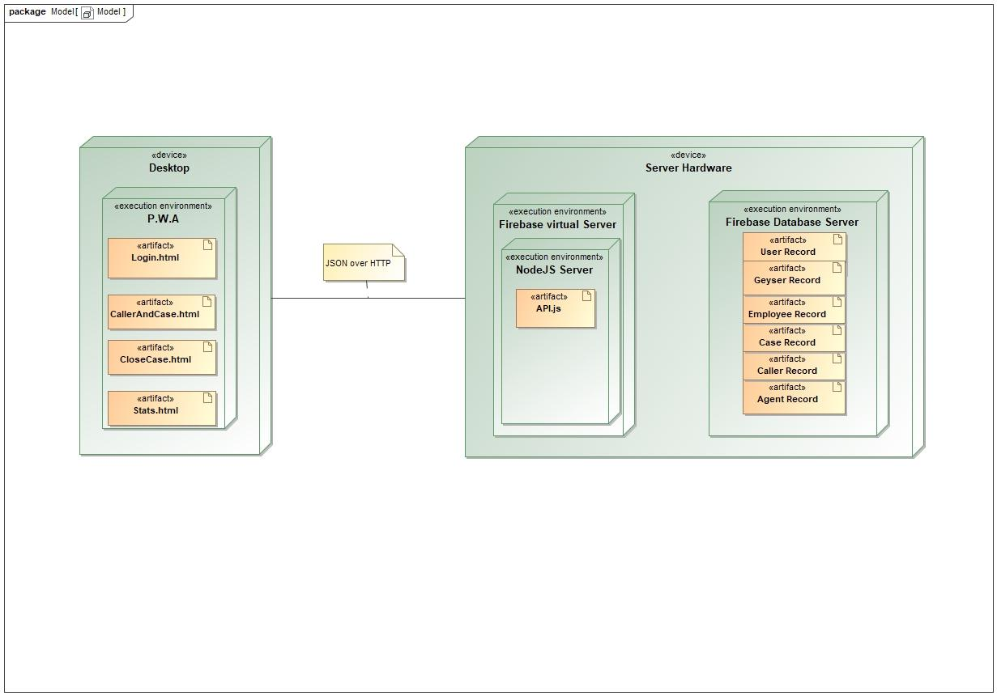

**This deployment model basically gives you an overview of the system and what artifacts and technologies are used to deploy this system.**

***Guidelines as how to use this website***

***Login Page***

**=> If you are not a new agent then enter your credentials in order to proceed.**

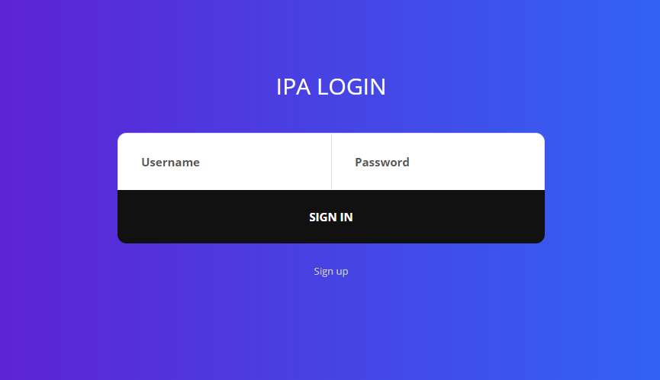

**Signup Page**

* **If you are a new agent, you have to signup first and then login to proceed**.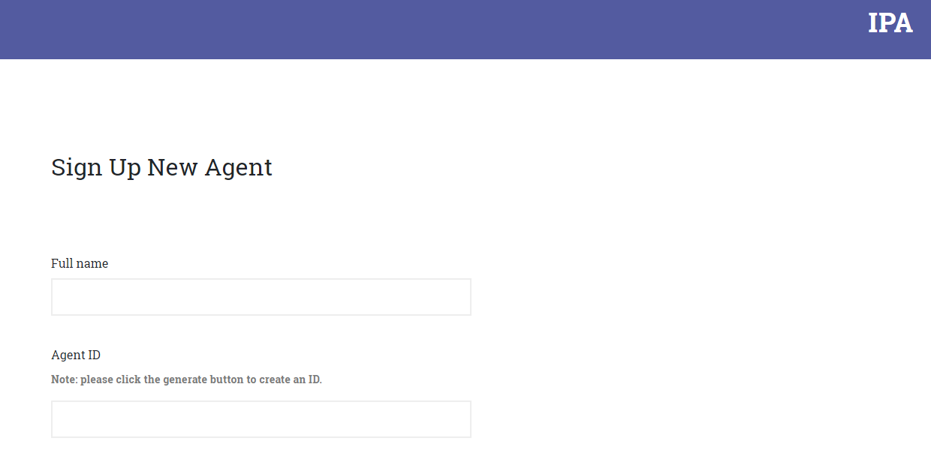

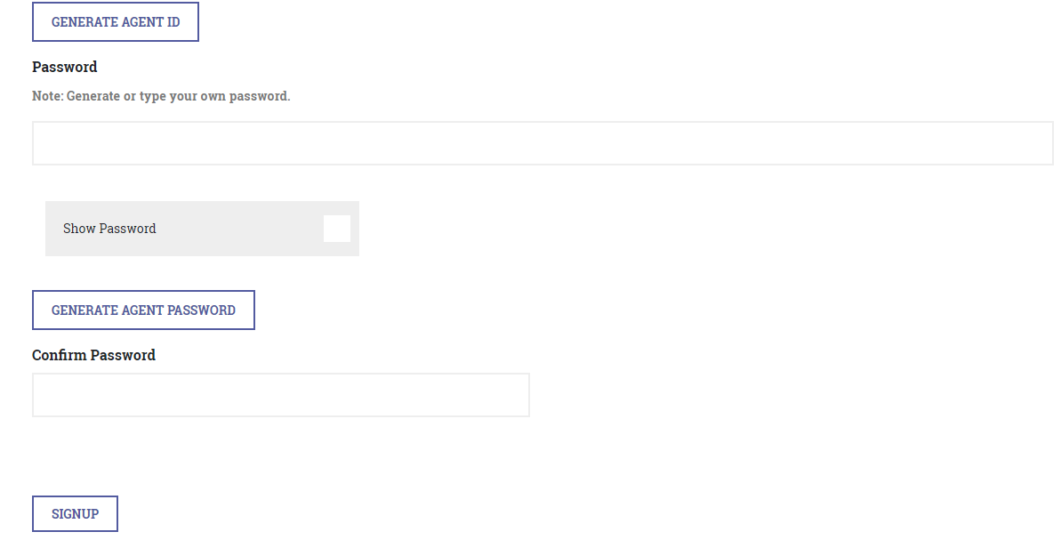





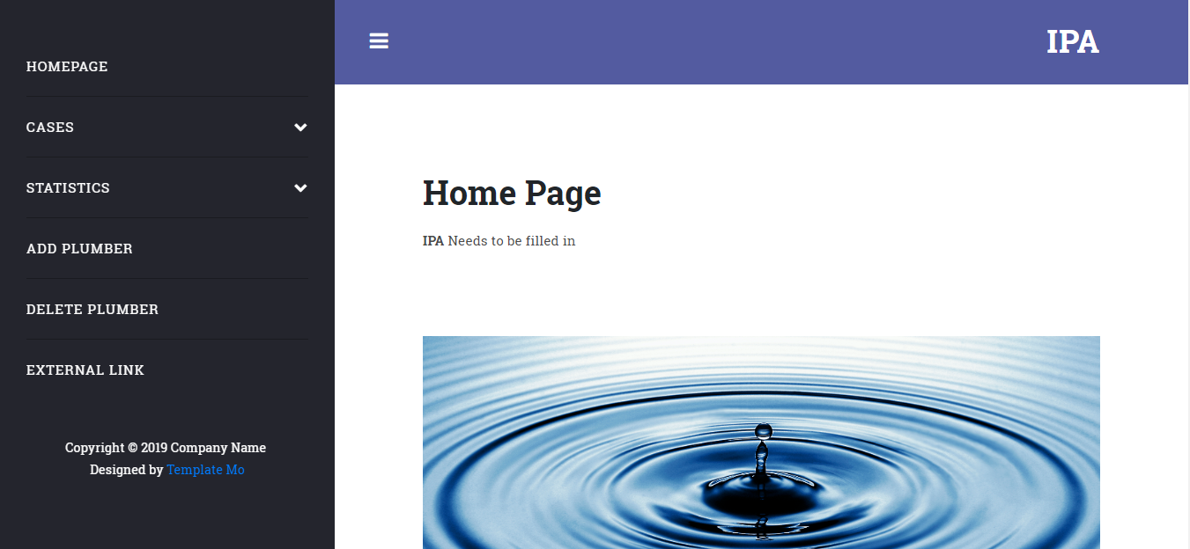

**Entering details of a new case**





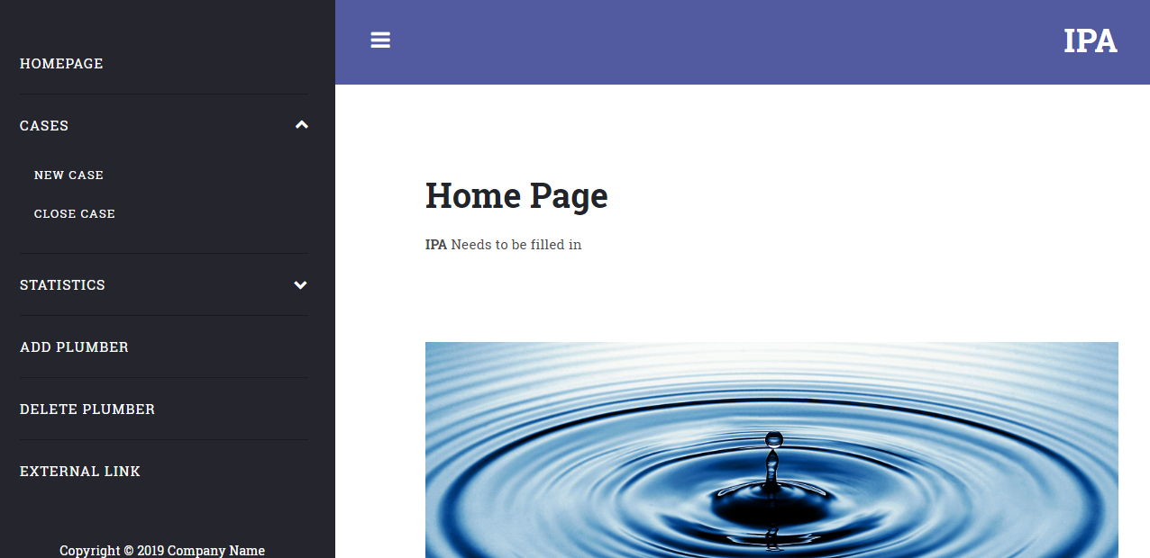

**Below is the form to fill in the details related to a case**.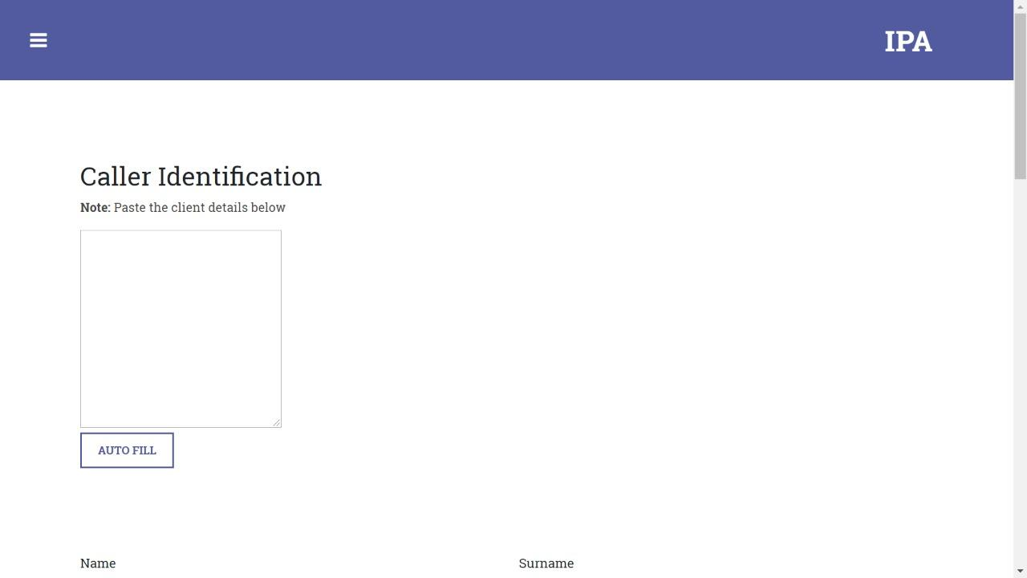

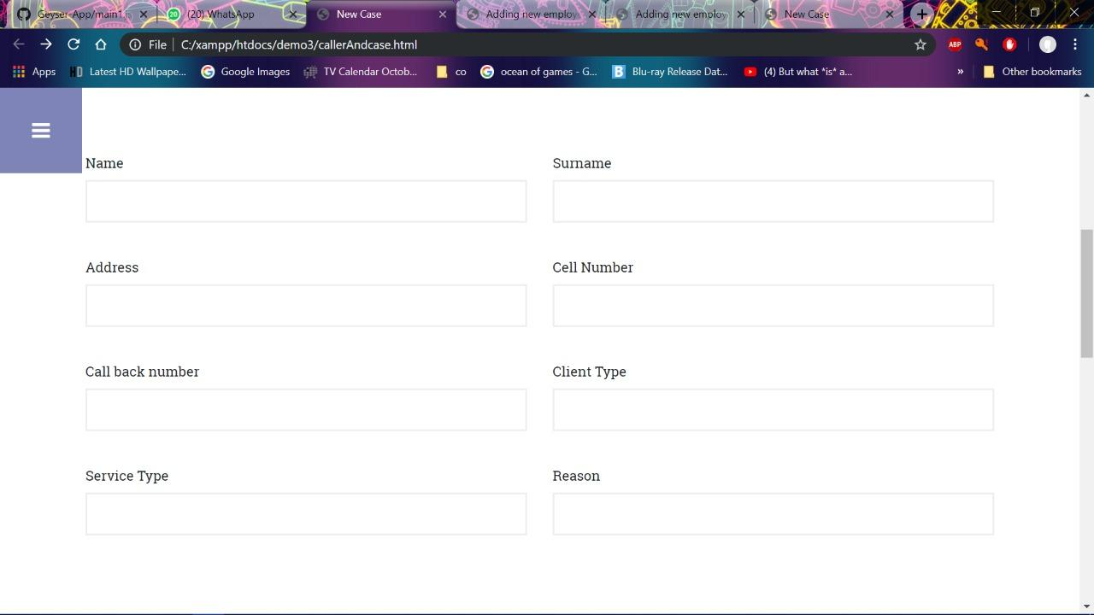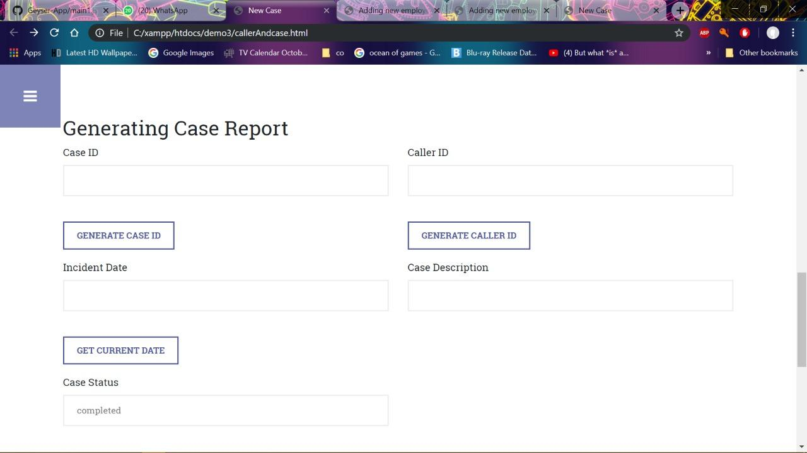

blob:https://web.whatsapp.com/e24d18bb-c561-4580-ab8f-af8e683fa072

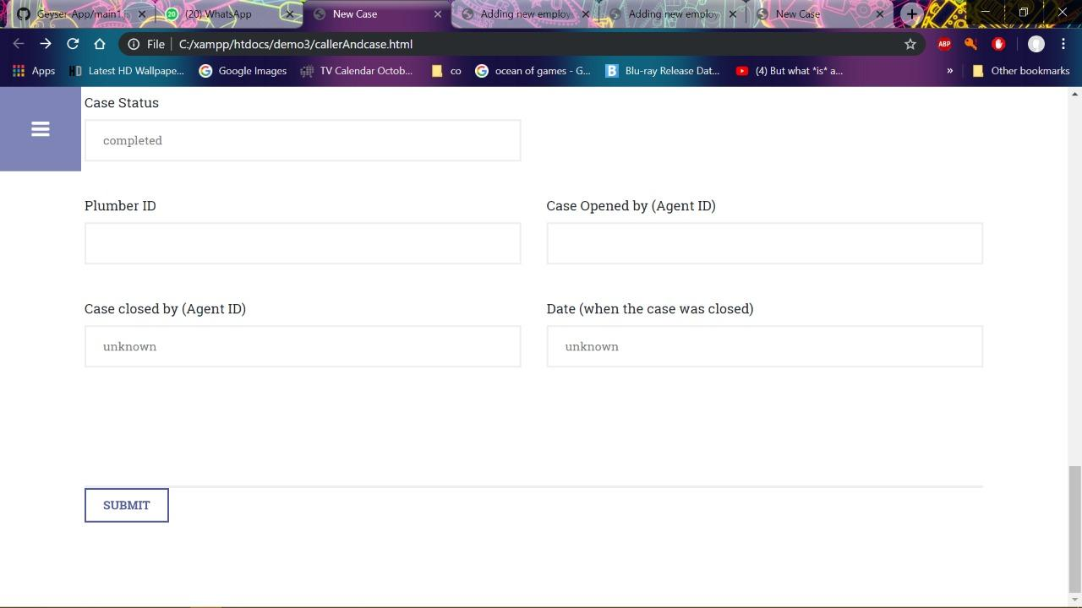



**Closing a case**

* **To close a case click here**:

**By clicking on the “view cases that needs to be closed “ button , a list of cases will be displayed that needs to be closed and then enter you agent ID in order to close it. Below is an example as how to close a case/cases.**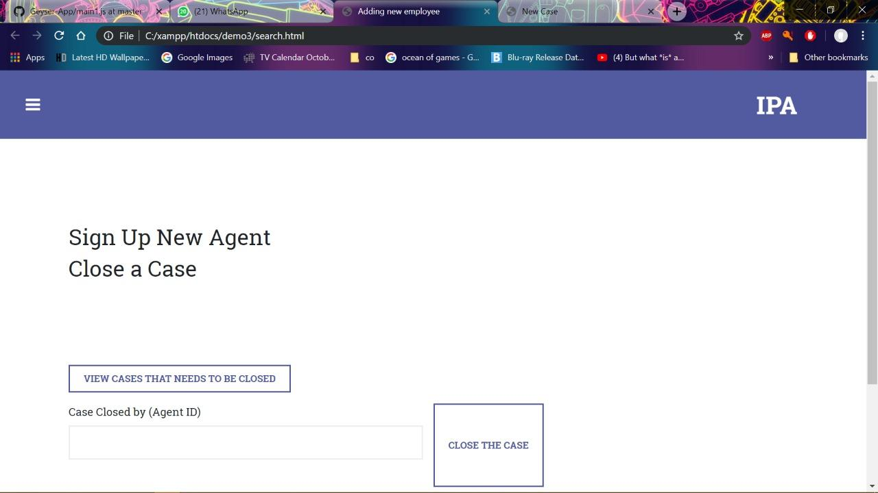

**When “view case that needs to be closed” button clicked a list of cases are shown:**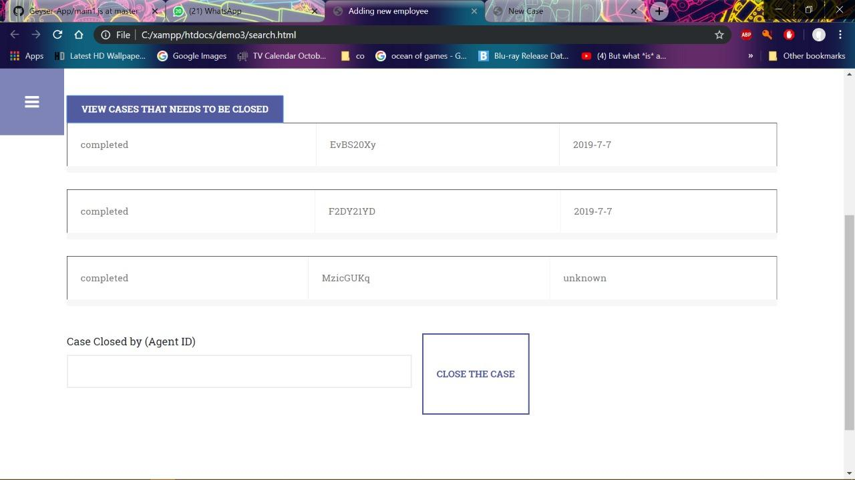

* **Choose your agent ID from the drop down and click submit.**

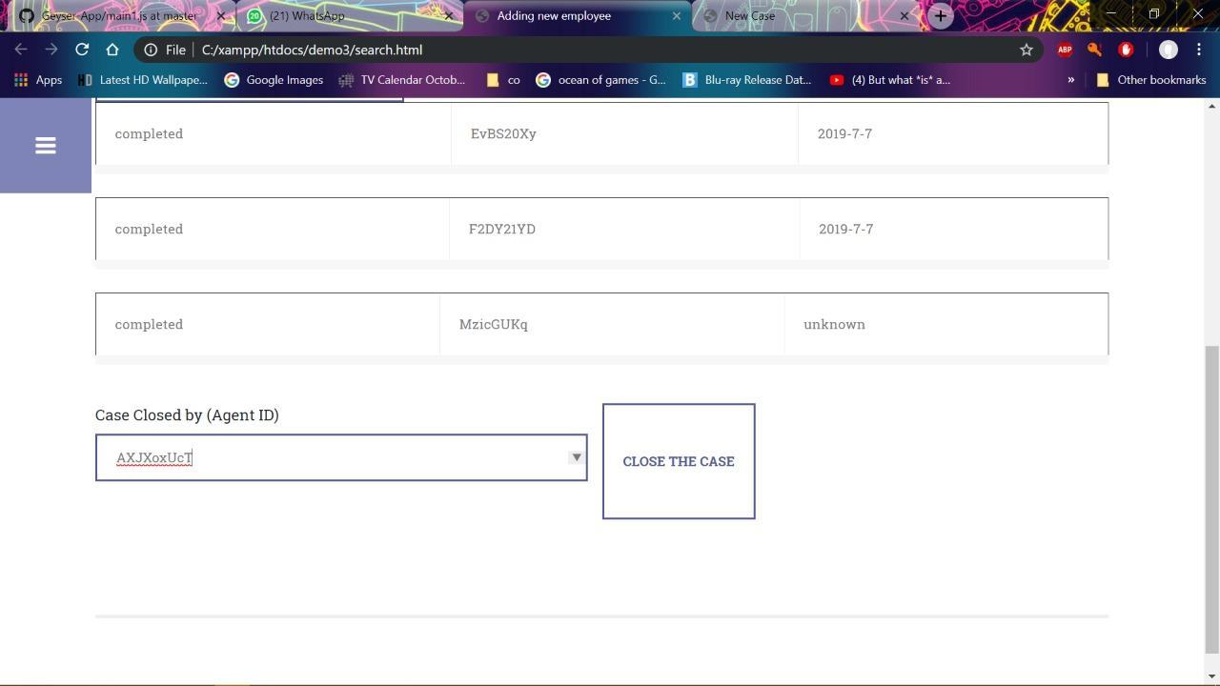

**Searching for cases handled by a specific plumber**

* **To perform search functionality click here:**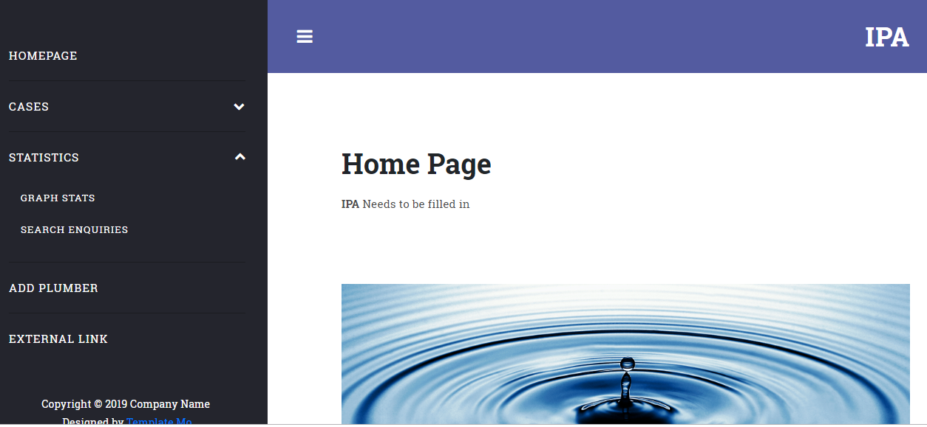

**Enter the plumber’s ID to get details on the cases handled by a specific plumber.**

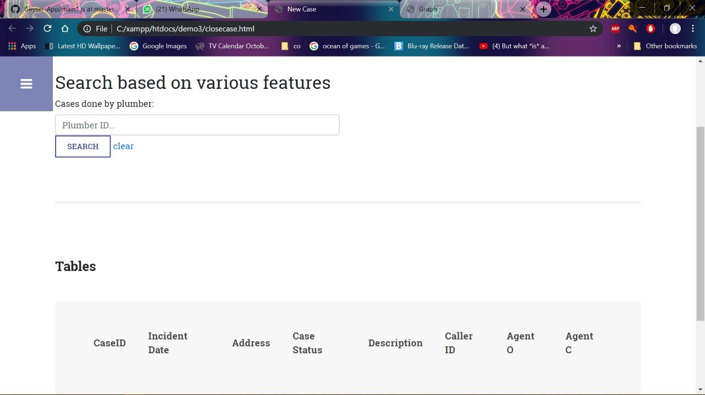

**Example of searching for case handled by plumber ID 24DhAjwRbi**

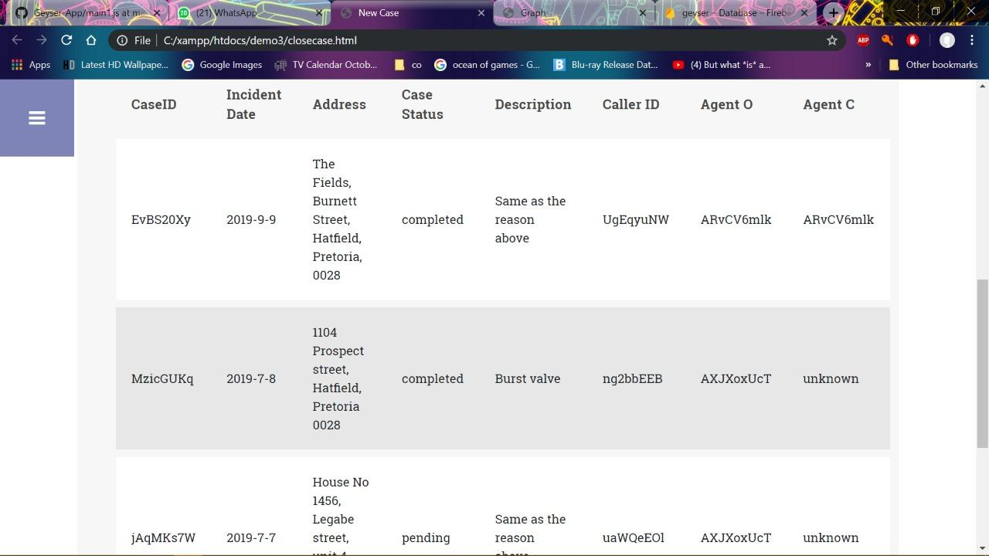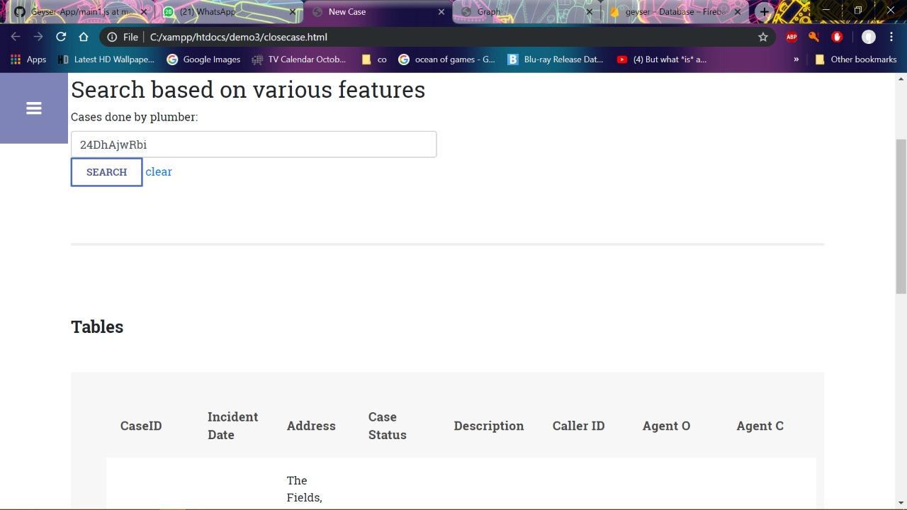

***Statistics***

**To view Statistics, click here :**

**Click on the button called “view number of cases per month “ to get an overview of the cases handled per month.**

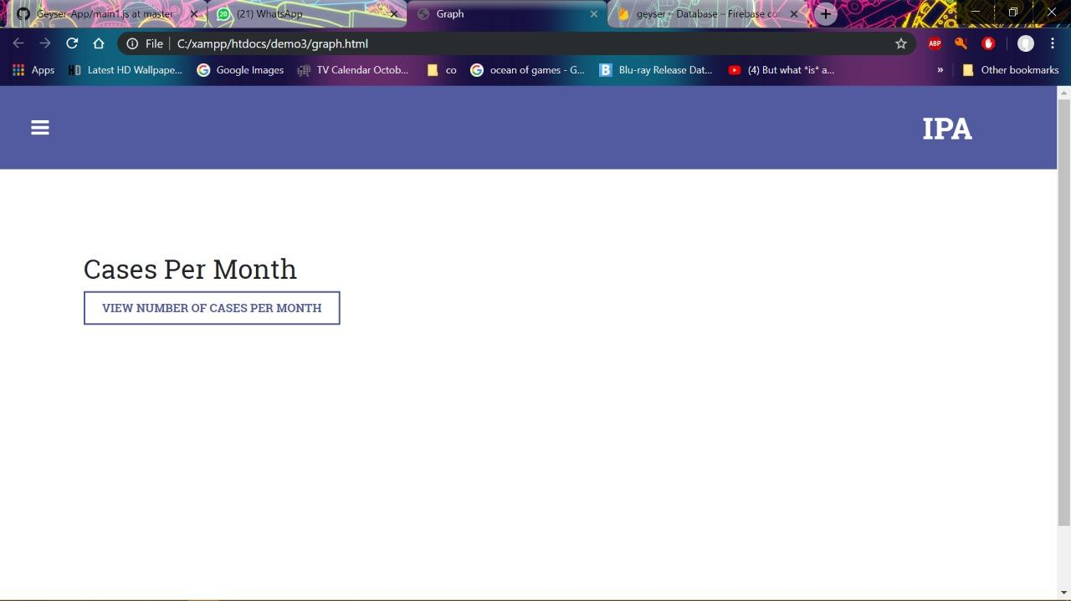

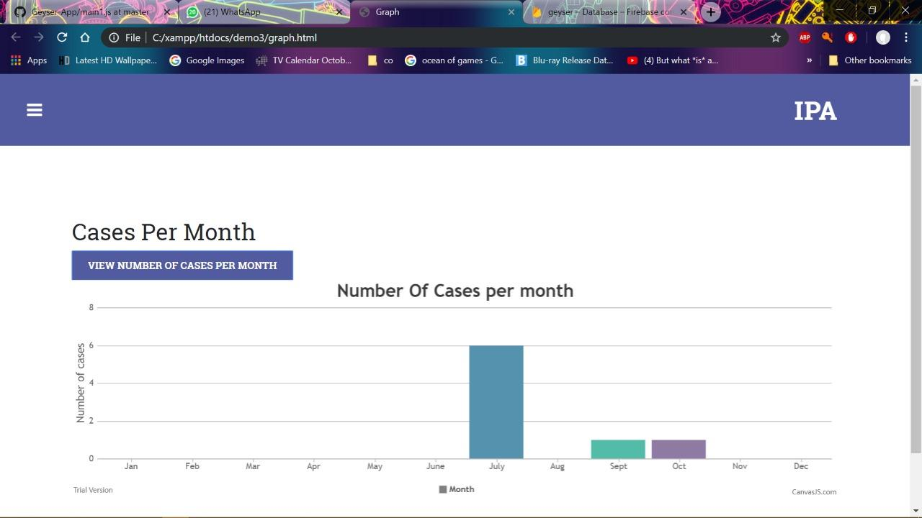

***Adding a new employee***







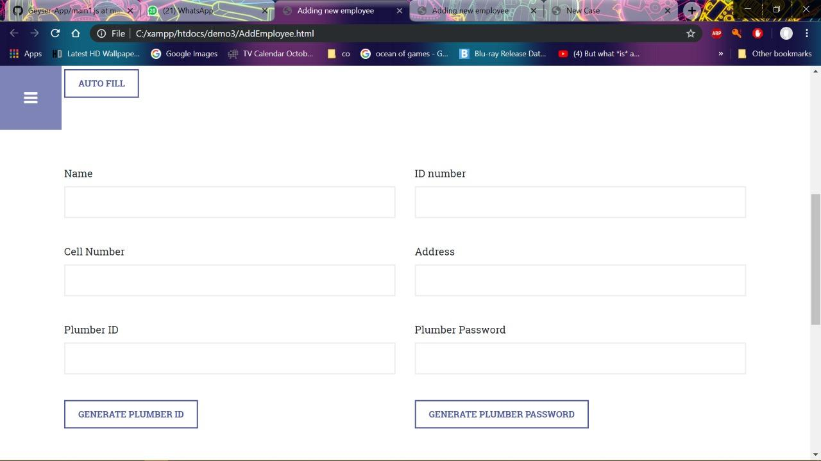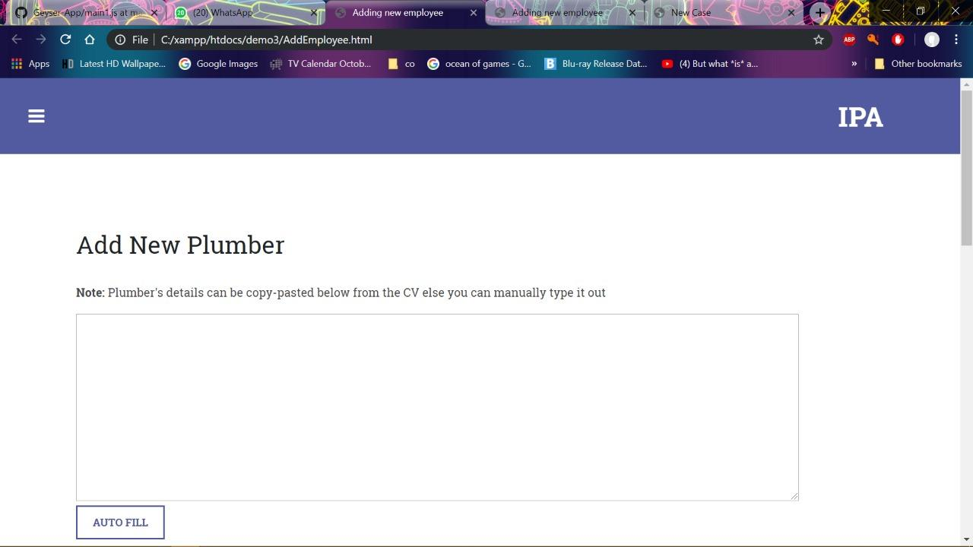

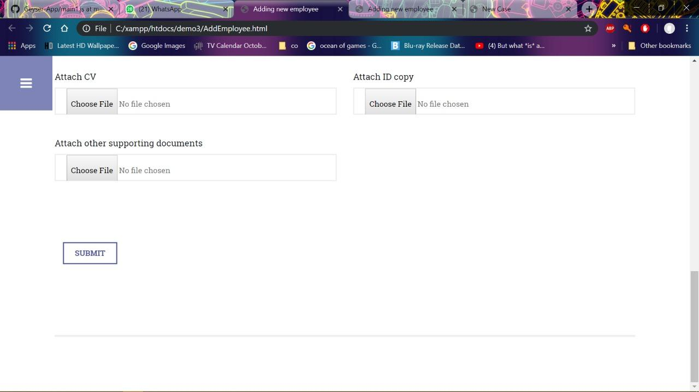

**Deleting an employee**

**In order to remove an employee’s records from a database, insert the plumber’s ID .**

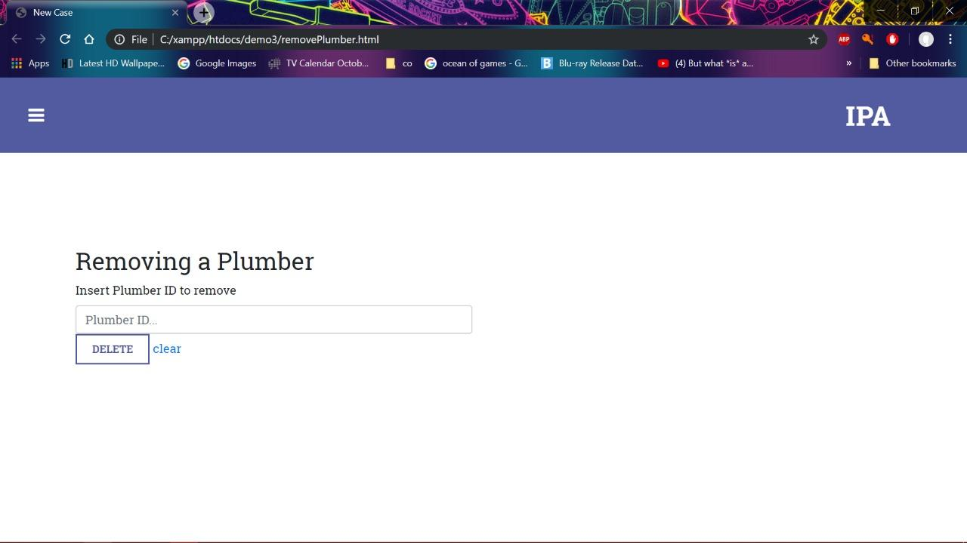

***Example of deleting an employee’s record from the database.***

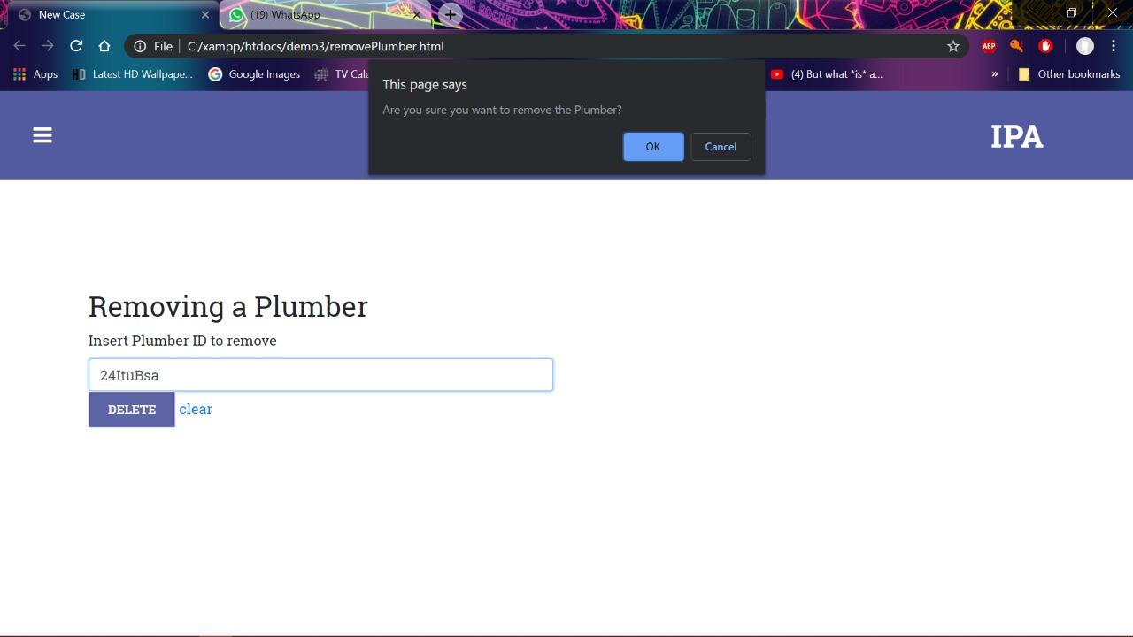

***Troubleshooting***

Error messages will appear if required fields that need to be filled in have been left blank. In this instance an error message in red will appear underneath the required field. This occurs when filling in case details, new employee’s details, login and sign up page. This can be avoided by filling in the required fields.

**Section 2 - Plumber app**

## System Overview

Summary: Information about the geyser and its installation, including relevant documents, are recorded and kept on a database in order to ease the installation process.

Plumbers: The app intends to help the user through any documentation a they might do for a geyser installation/repair.

Homeowners: The app intends to provide a way for users to access information about their registered geyser(s).

Administrators: User data is stored online in a remote, secure database for any queries that the admin requires data for.

## System Configuration

This app works on all mobile devices running an Android Operating System, minimum version Oreo. The app communicates with the database on two occasions, one for a login process and once more when either retrieving or sending records from the database for an installation/repair or a data query. The application requires any internet connection to work.

## Installation

This software is provided by the administrator. The APK for installation can be found on our project Github page under the "Build" folder. To install simply run the apk on the device and when prompted whether sure or not press "install anyways".

## Getting Started

In order to get a license one must consult an administrator for them to create an account for you. Once this is done input your userID and password into the fields on the main screen in order to log in. As of the current version there is no way to change userID or password other than to contact the administrator and request a change.

A typical walkthrough of the app: Login using userID and password. Scan the barcode as per the onscreen prompts. Press on "Open Camera" to open the camera and take a picture of the appropriate component as per the prompt on the screen. This repeats for 4 more cycles. The user can choose to retake a photo if they wish to. Finally input all appropriate details into the form and confirm the details, all fields are required.

To exit the application, use the phone's back function until you return to the "Dashboard" then press "Logout".

## Using the System

### Logging in

This is the login screen and also the first screen you see upon opening the application.

1. The userID field is where you input your userID.
2. The password field is where you input your password.
3. Press the login button once both fields have been filled to login. A password is necessary as otherwise unauthorized users would have access to information and we wouldn't be able to accurately retrieve/send data to your own corresponding records.

**Dashboard**

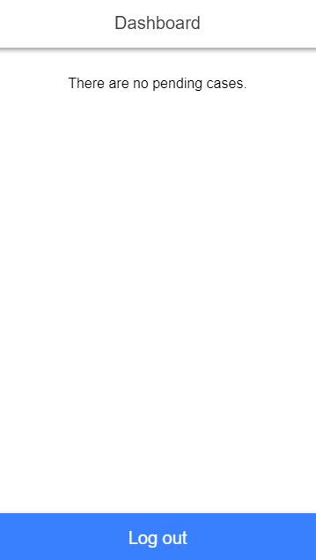

This is the Dashboard. Should the user have a pending case to work on the dashboard will be skipped and the process for installation/repair will automatically begin, else the user will be told they have no pending cases and can log out.

**Barcode Scanner**

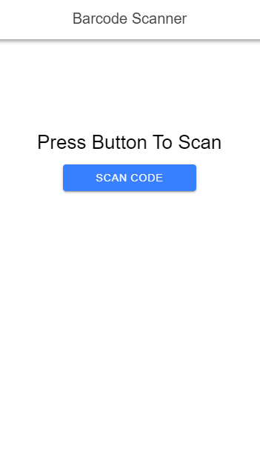

There is only one pressable button here and it is the "Scan code" button. Press this button to open the barcode scanner and place the barcode within the field to scan it. This identifies the geyser that the user will be working on.

**Camera**

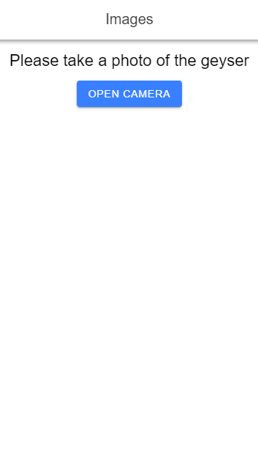

This screen prompts the user to take pictures of the corresponding geyser part. Pressing the "Open Camera" button will open the camera to take a picture. Once a picture has been taken the user will be given a preview of the picture and the option to retake the picture using the "Retake picture" option depicted below. If the user is satisfied with the picture they can press the "Confirm" button to proceed to the next image.

**Geyser Detail Capture**

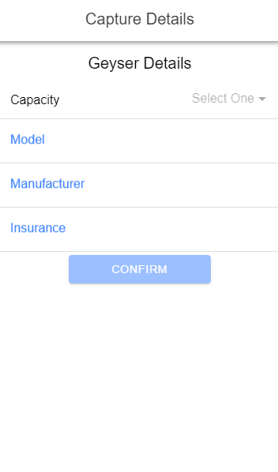

All details from top to bottom: Capacity, Model, Manufacturer, Insurance must be filled out and are required in order to be able to press the "Confirm" button and send the details to the database. This is especially important as this is the step where the data is sent to the database. The actual sending only happens after pressing "Confirm". An alert will inform the user that the details were sent. Capacity is a drop down list to conform to database values.

## Troubleshooting

Error messages will appear if required fields that need to be filled in have been left blank. In this instance an error message in red will appear underneath the required field. This occurs on the login page and on the details page. This can be avoided by filling in the required fields.